Machine Learning

**Contents:**

1. **Introduction**
   1. What is Machine Learning?
   2. Why machine learning?
2. **Foundations**
   1. Basic concepts associated with Machine Learning
      1. A Formal Model

Will contain definitions of

Learning Input terms like domain set, label set, training data and test data.

Learners output

Simple data-generation model

Measure of success

* + 1. Multiclass Classification

Classification need not be binary. Example of a multiple category classification to apply machine learning.

* + 1. Regression

Briefly describing the concept of regression. Explained with an example of predicting expected salary based on years of experience.

* + 1. Overfitting

Explanation of the fact that the model is always build on a sample of data and needs to be more general.

Problems associated with overfitting

* 1. Probability
     1. Introduction

How probability is important in the field of machine learning.

* + 1. Fundamental rules

Brief description of the following topics (not in depth as it is not required). Basic understanding and small examples.

* + - 1. Mutually exclusive events
      2. Independent events
      3. Dependent events
      4. Conditional probability
      5. Bayes Rule
      6. Random variables
      7. Mean, variance and standard deviation
      8. Correlation
    1. Types of distribution

Each of the distribution is explained through their graph to help visualize along with their probability distribution functions.

* + - 1. Binomial and Bernoulli distribution
      2. Normal and Standard normal distribution
      3. Other different types of distributions not frequently used

1. **Classification of Machine Learning**
   1. Supervised Learning

Predefined fields required, definition followed by an example.

* 1. Unsupervised Learning

About clustering and general definition followed by an example.

* 1. Linear Regression

About linear regression.

Choosing of appropriate parameters using the correlation coefficient, domain knowledge etc.

Plotting the best fit line

Calculating errors

* 1. Logistic Regression

About Logistic regression

Choosing of parameters

Plotting the best fit line and then applying the sigmoid function

Setting a threshold

Gathering output

Construction of the confusion matrix

* 1. Naïve Bayes classification
     1. Applying Bayes theorem to machine learning

Independence of columns

* + 1. Drawback

Doesn’t take in to account the derived columns explain with example

* 1. Decision Trees

Description, example, graphs and different ways in which decision trees can be applied

* 1. Random Forests

Emphasis Wisdom of crowd is better than wisdom of individual

Getting importance of different variables in the data

Application and High levels of accuracy achieved

1. **Kernels**
   1. What are kernel functions

When the objects we wish to classify do not have a fixed-size feature vector, representation of such objects are done using kernel functions.

Description and brief discussion on different type of kernel functions

* 1. Support Vector Machines

What are support vectors? Formula and explanation of formation of a SVM by the combination of a kernel and a modified loss function.

1. **Future of machine learning**
   1. Trends in research
   2. Scope of machine learning

**1. Introduction**

“Humans learn from experience, machine learns from data.”

This is the *mantra* of machine learning. Just like a small child fears inserting his finger inside a candle flame only after getting burnt once, i.e., only after experiencing the pain associated with the heat caused by the candle flame when he/she does it for the first time and gains experience that doing so is painful, will the child avoid repeating the action. The baby learns from its past experience that the flame is dangerous. Similarly, machines learn from data we provide them to evaluate and hence take the right actions.

We wish to program computers so that they can “learn” from input available to them. Learning is the process of converting experience into expertise or knowledge.

1.1 What is machine learning?

We can define machine learning as a set of methods that can automatically detect patterns in data, and then use the uncovered patterns to predict future data, or to perform other kinds of decision making processes with certain uncertainty or we can call it probability. Consider an example similar to the baby putting a finger in fire,

*Bait Shyness* - *Rats Learning to Avoid Poisonous Baits*: When rats encounter food items with novel look or smell, they will first eat very small amounts, and subsequent feeding will depend on the flavor of the food and its physiological effect. If the food produces an ill effect, the novel food will often be associated with the illness, and subsequently, the rats will not eat it. Clearly, there is a learning mechanism in play here: the animal used past experience with some food to acquire expertise in detecting the safety of this food. If past experience with the food was negatively labeled, the animal predicts that it will also have a negative effect when encountered in the future.

Now, suppose we would like to program a machine that learns how to filter spam e-mails. A naïve solution would be that the machine will simply *memorize* all previous e-mails that had been labeled as spam. So that when a new e-mail arrives the machine will search for it the memory and segregate accordingly. While this process of “learning by memorization” is useful, it lacks – the ability to label unseen e-mails. A successful learner should be able to progress from individual examples to broader generalization. This is also referred to as inductive reasoning or inductive inference. To achieve generalization in the spam filtering task, the learner can scan the previously seen e-mails, and extract a set of words whose appearance in an e-mail message is indicative of spam. Then, when a new e-mail arrives, the machine can check whether one of the suspicious words appears in it, and predict its label accordingly.

Such tasks cannot be coded, the reason for which can vary from not having proper distinction between the classifications to having too many classifications. Hence, machine learning.

1.2 Why machine learning?

“We are drowning in information and starving for knowledge.” — John Naisbitt.

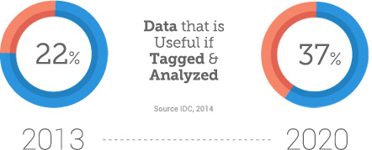

We are entering the era of **big data**. Data is being generated at unprecedented rates today, with each new technological advancement spurring it on even further. Internet of Things, machine learning, and the digitization of health care will soon be generating millions of gigabytes per second. Self-driving cars, too, are soon expected to enter this realm with the generation of 350 MB of data per second by 2020, according to an IMB study. The same study stated that 80 percent of all data collected today is ‘dark’, that is, it’s inactive and incoherent. An IDC study predicts that the digital universe will expand to 44 zettabytes (or 44 trillion gigabytes) by 2020.

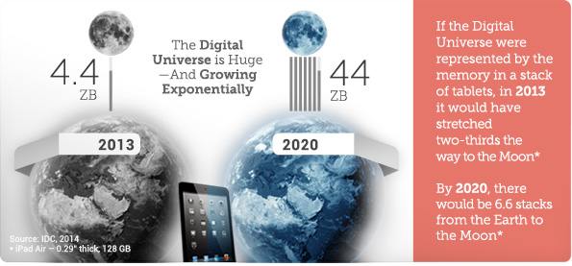

This deluge of data calls for automated methods of data analysis, which is what **machine learning** provides. Machine learning aids the developers in tasks that are too complex to program, where there is need to improve on the basis of their “experience”.

* Tasks performed by humans/animals:

There are numerous tasks that we human beings perform routinely, yet our introspection concerning how we do them is not sufficiently elaborate to extract a well-defined program. Examples of such tasks include driving, speech recognition, and image understanding. In all of these tasks, state of the art machine learning programs, programs that “learn from their experience,” achieve quite satisfactory results, once exposed to sufficiently many training examples.

* Tasks beyond Human Capabilities:

Another wide family of tasks that benefit from machine learning techniques are related to the analysis of very large and complex data sets: astronomical data, turning medical archives into medical knowledge, weather prediction, analysis of genomic data, web search engines, and electronic commerce. With more and more available digitally recorded data, it becomes obvious that there are treasures of meaningful information buried in data archives that are way too large and too complex for humans to make sense of. Learning to detect meaningful patterns in large and complex data sets is a promising domain in which the combination of programs that learn with the almost unlimited memory capacity and ever increasing processing speed of computers opens up new horizons.

One limiting feature of programmed tools is their rigidity – once the program has been written down and installed, it stays unchanged. However, many tasks change over time or from one user to another. Machine learning tools - programs whose behavior adapts to their input data - offer a solution to such issues; they are, by nature, adaptive to changes in the environment they interact with. Typical successful applications of machine learning to such problems include programs that decode handwritten text, where a fixed program can’t adapt to variations between the handwriting of different users; spam detection programs, adapting automatically to changes in the nature of spam e-mails; and speech recognition programs.

**5. Future of machine learning**

Every company is now a data based company, capable of using machine learning in the cloud to deploy intelligent apps at scale. Machine learning has the brightest future. No matter what you do, you are significantly going to be affected by machine learning. Everyone talks about automation, personalization, cognitive services and predictive analysis. The main theme of all the above mentioned fields is machine learning.

Artificial Intelligence and Machine Learning have taken the whole world by storm with all these stupefying inventions and cutting edge technologies coming into picture. Artificial Intelligence is quite an extensive field and it has the power and potential to take the mankind towards a far out future. Machine learning being a pivotal part of Artificial Intelligence has made quite a progress.

5.1 Trends in research

In the research areas, Machine Learning is steadily moving away from abstractions and extensively engaging in business problem solutions with the help of AI and Deep Learning. With Big Data making its way back to mainstream business activities, now smart (ML) algorithms can simply use loads of static and dynamic data to continuously learn and improve for enhanced performance.

* Deeper Personalization:

Users having more precise recommendations and advertisements becoming more effective than annoying.

* Neural networks running on mobile devices:

The thought of mobile devices being able to run neural networks locally to conduct machine learning tasks, opens up a wide range of opportunities for object recognition, speech, face detection etc.

* Real-time speech translation:

In late 2014 Skype launched Skype Translator. It has been improving since then, and currently provides real-time audio translation from eight languages. If this technology continues to develop, it could significantly improve the quality of international communication or even eradicate language barriers.

* Health and fitness:

Fitness tracking wearables and apps are gladly used by people to track their sport activities and everyday life. Machine learning has the potential to take it a step further, by providing more detailed feedback and tips about the user’s activity and condition, making fitness trackers more effective.

These are just to name a few of the fields where we can see great development in the near future.

5.2 Scope of machine learning

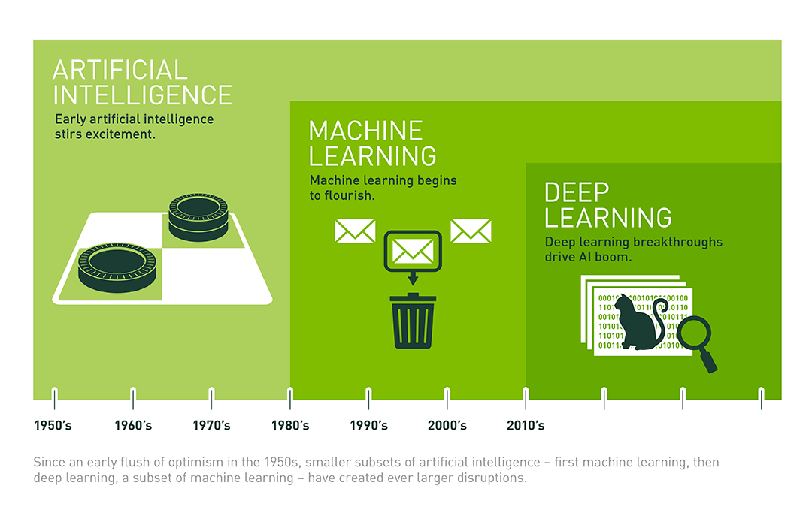

The lethal combination of artificial intelligence and machine learning will be delivering more systems that “understand, learn, predict, and potentially operate autonomously”. Cheap hardware, memory, storage technologies, more processing power, superior algorithms, and massive data streams all contribute to the success of ML-powered AI applications.

Rise of applications can be seen in sectors like healthcare, banking, finance and media. For business more automated functions imply fewer human checkpoints. Democratization through cloud technologies, open standards, and help the algorithms economy to develop. Enterprise apps, productivity apps, and mobile apps will become increasingly smart by embedding learning capabilities or other forms of AI like use of NLP (natural language processing), machine vision and voice interface into the apps.

The most powerful form of machine learning being used today, called “deep learning”, builds a complex mathematical structure called a neural network based on vast quantities of data. Designed to be analogous to how a human brain works, neural networks themselves were first described in the 1930s.

The provisioning of Cloud-based IT services was already a good step to make advanced Data Science a mainstream activity, and now with Cloud and packaged algorithms, mid-sized and smaller businesses will have access to Self-Service BI (Business Intelligence) and Analytics.

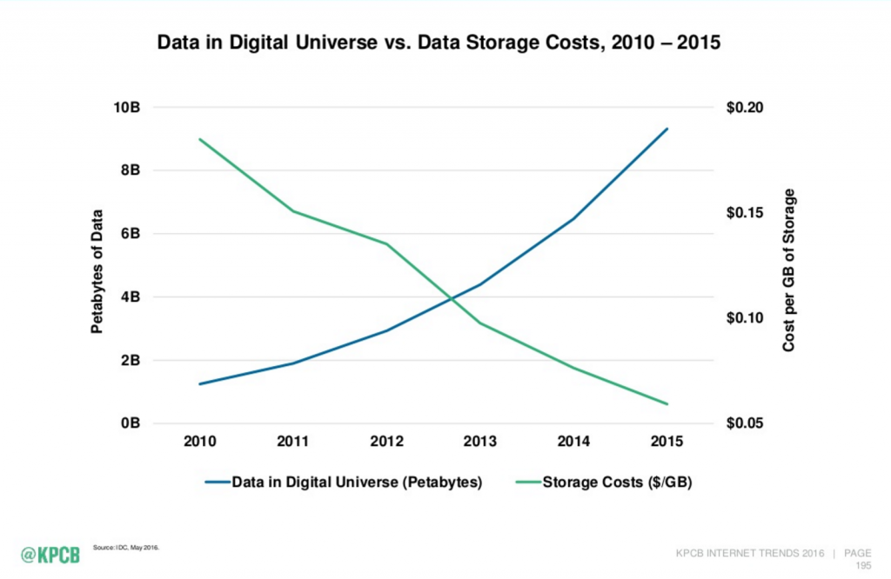

The possibilities that can be achieved with the help of machine learning is way beyond what a human can achieve.